Name

Practice Problems- Unit 2B

Particle Models, Explanations & Experimental Design

- Draw a particle diagram to represent the relative movement of solids, liquids, and gasses.

- When do scientists revise or change their models?

- Explain how liquid can be drawn up a straw (or “sucked” up a straw).

- Why is it hard to drink with a straw that is cracked? Draw a particle model to help support your explanation.

- Why is it hard to drink from a very, very long straw? Draw particle model to help support your explanation.

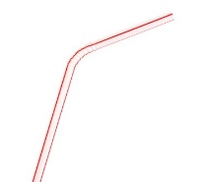
- Why couldn’t your teacher drink from a sealed container with the straw and stopper? Draw particle model to help support your explanation.

- A lab group completed Pop Can Challenge Part 1, however their can did not crush. What could explain this? (List a least three different scenarios)

- In Pop Can Challenge Part 2 there were many groups that had a variable that did not crush. List three different variables that created no crushing. Explain why each example did not crush.

- Complete the chart below:
Experimental Design | Definition | Link to Pop Can Challenge
Independent Variable
Dependent Variable
Control
Constant
Results- Can be either:
Qualitative

Quantitative

- What is the difference between a hypothesis and a claim?

- What is the difference between law and a theory?

- Summarize the kinetic molecular theory

