Name _______________________________________ Date Due: __________ Period: _____
- Find the circumference.
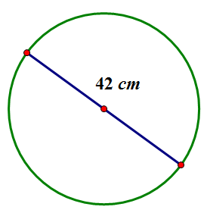
  - Give an exact answer in terms of $π$.

  - Use $π≈\frac{22}{7}$, and express your answer as a fraction in lowest terms.

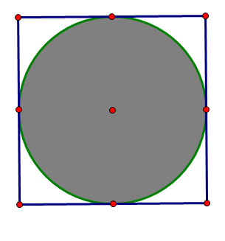
$$16 in.$$
- The figure shows a circle within a square. Find the circumference and area of the circle. Let $π≈3.14$.

- Find the perimeter and the area of the semicircle. Let $π≈3.14$.
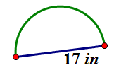

- Ken’s landscape gardening business makes odd-shaped lawns that include semicircles. Find the length of the edging material needed to border the lawn design shown below. Use $3.14$ for $π$.
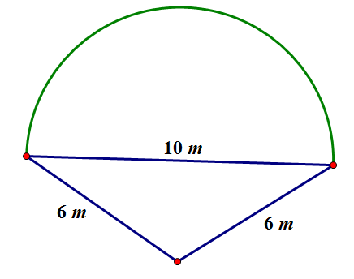

- The following circles are not drawn to scale. Find the area of each circle. (Use $\frac{22}{7}$ as an approximation for $π.$)
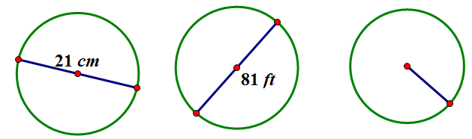
$$\frac{45}{2}cm$$

- A window manufacturer designed a set of windows for the top of a two-story wall. If the window is comprised of $2$ squares and $2$ quarter circles on each end, and if the length of the span of windows across the bottom is $12$ feet, approximately how much glass will be needed to complete the set of windows?
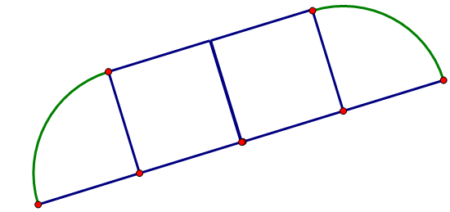

- Find the area of the shaded region. (Approximate $π$ to be $\frac{22}{7}$.)
