Homeroom Based Grade Book

**Accessing Grade Book**

Log In to TeacherVue

Click the Icon to launch Gradebook 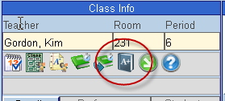

**Grade Book Setup**

Hover over the Grade Book Menu and select Grade Book Setup.

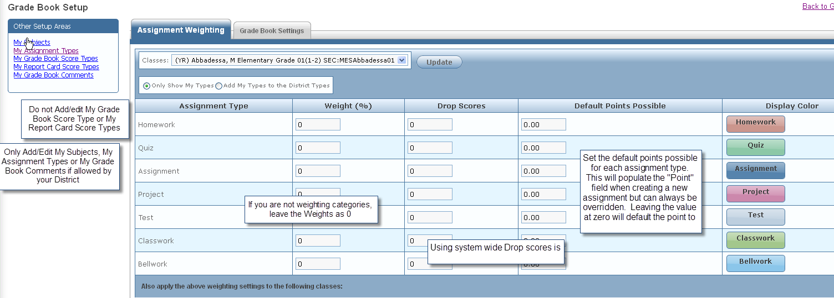

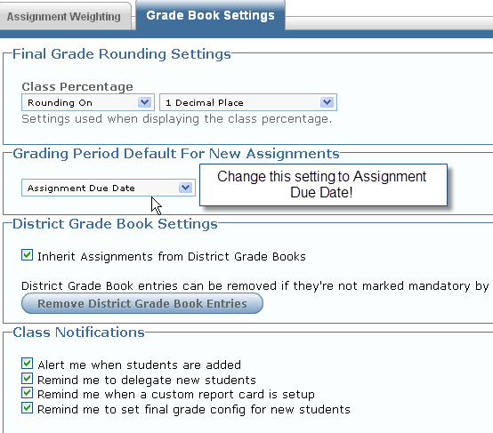

Notes:

**Creating Assignments**

Hover over the Grade Book Menu and select New Assignment or click on the New Assignment button from Grade Book Main.

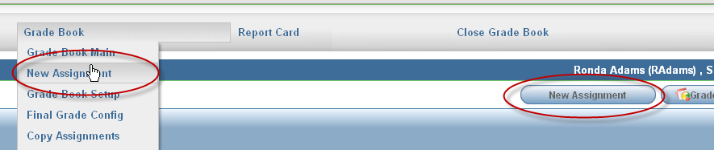

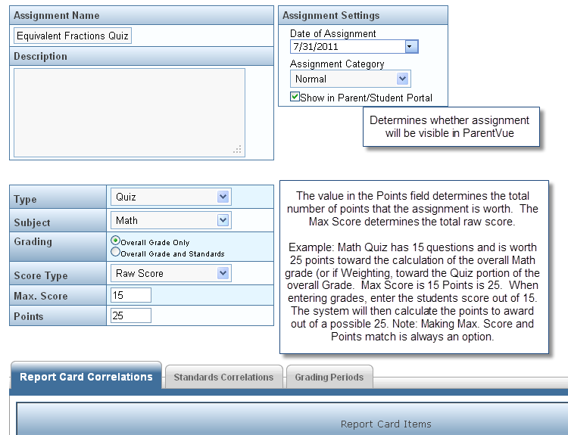

Scroll down to Correlate the assignment to the applicable report card areas.

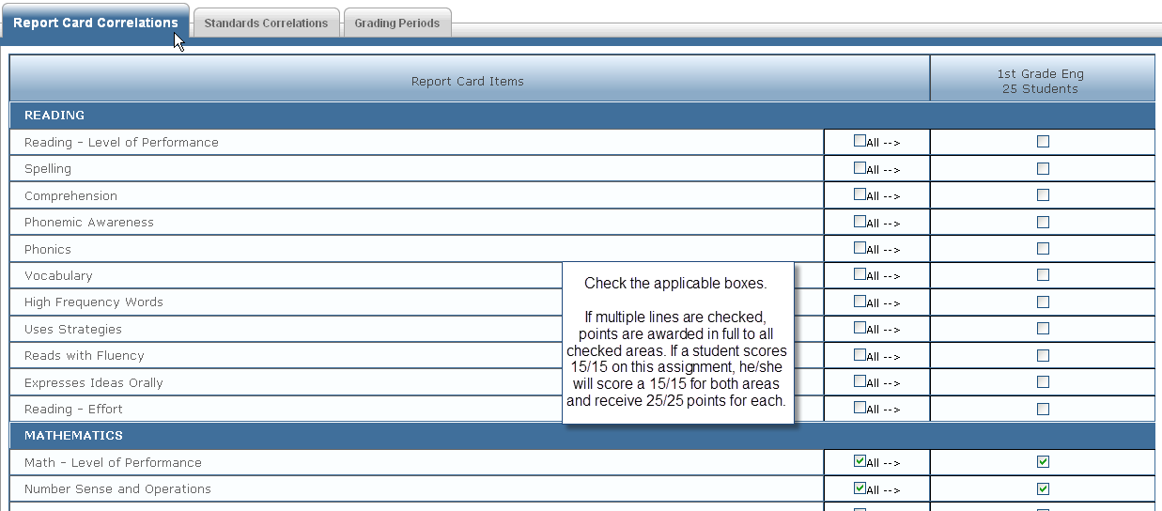

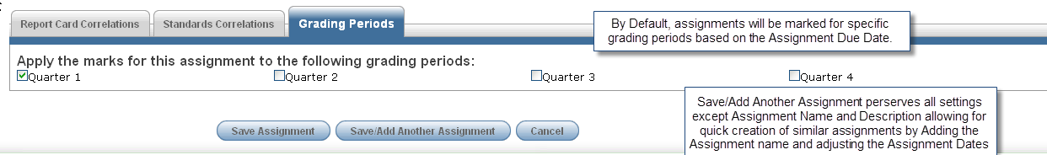

Notes:

**Entering Scores**

From Grade Book Main, Click on the Heading of the assignment and Select Enter Scores

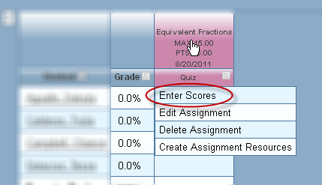

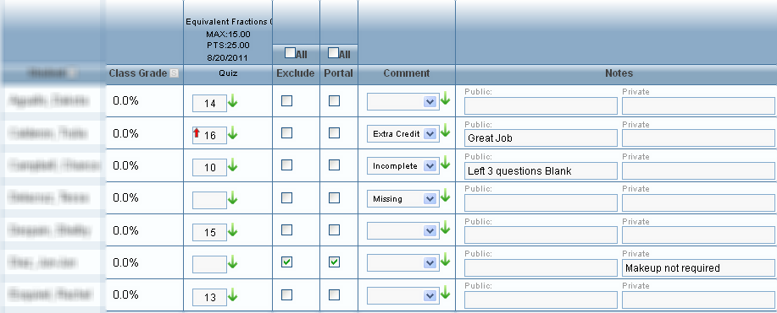

* Green (down) arrow fills the score or comment down from the arrow clicked.
* Red (up) arrow indicates score entered is higher than the max.
* Checking exclude drops the grade so that it doesn’t count for or against the student.
* Checking Portal hides the assignment so that it doesn’t show in Parent Vue.
* A “Missing” comment may be set to count as a “0”.
* Public comments can be seen in ParentVue.

**Entering Scores in Gradebook main in Grade Book Main**

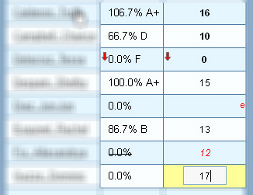

Click in cell, enter score. Score remains red and previously calculated grade is lined out until changes are saved.

The Red (down) arrow indicates the score fell below the “at risk” level.

Notes:

**Create Assignment Resources**

From Grade Book Main, Click on the Heading of the assignment and Select Create Assignment Resources

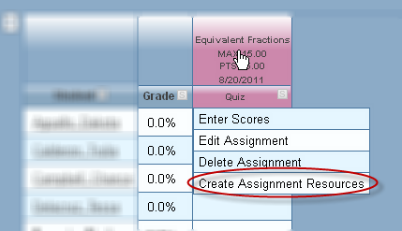

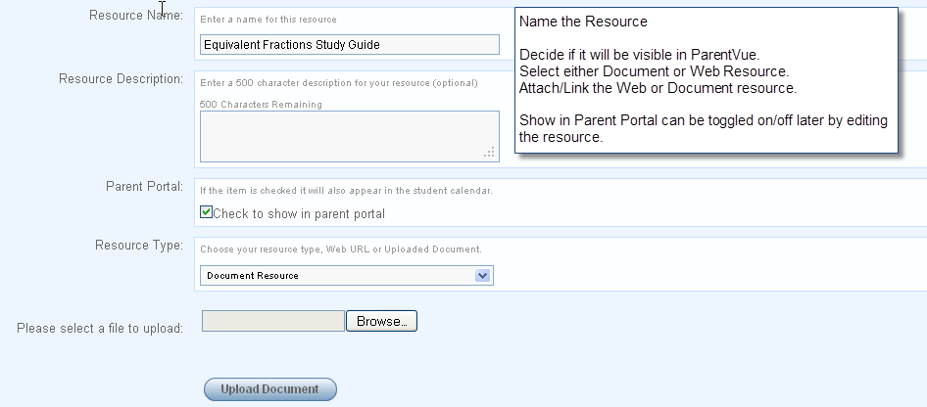

**Edit or Delete an Assignment Resource**

Click on the Column Heading of the Assignment that the resource is linked to and select Create Assignment Recourses. Existing resources are listed at the bottom of the window.

Click Edit (or Delete if desired)

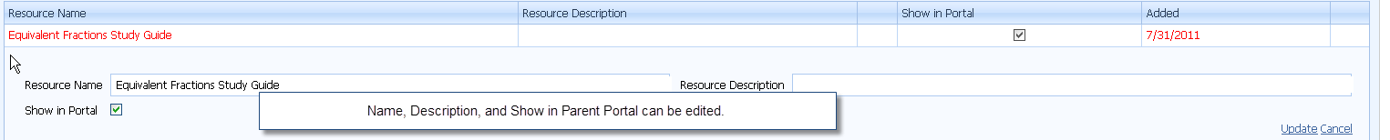

Notes:

**Report Cards –Report Card Preview (Transfer Calculated Scores to the Report Card)**

Hover over the Grade Book Menu. Select Report Card Preview.

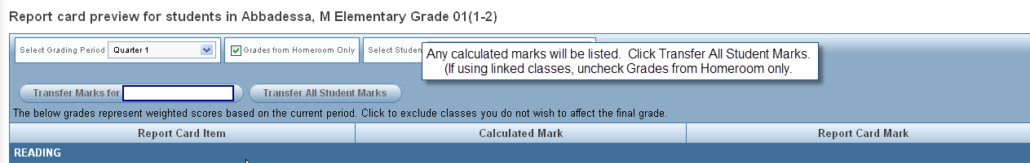

**Report Card – Report Card Matrix (Edit/Add Scores by report card area)**

Hover over the Report Card Menu. Select Report Card Matrix.

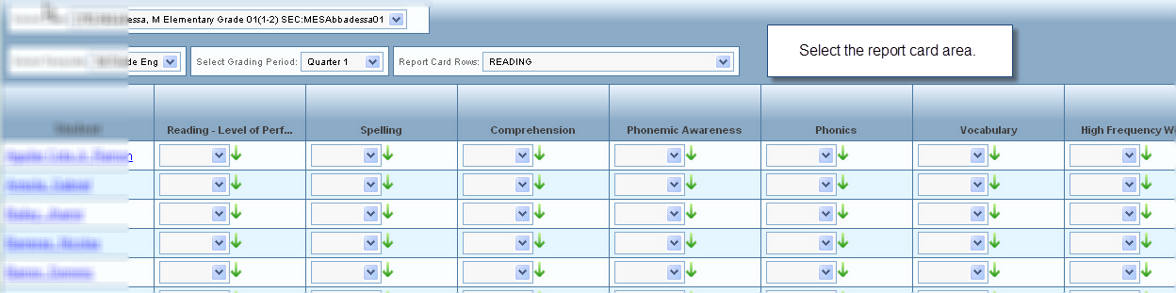

Calculated marks will already be populated in the applicable areas. (See Report Card Preview) Fill in remaining scores. The green (down) areas can be used to fill down marks for all students.

**Report Card – Student (Finalizing the Report Card, Entering Comments)**

Hover over the Report Card Menu. Select Students.

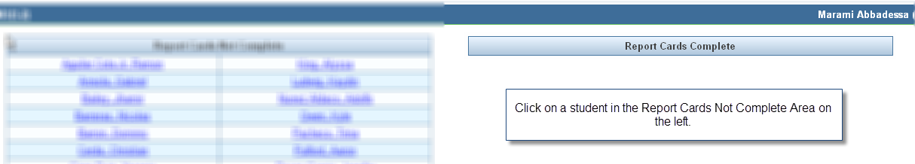

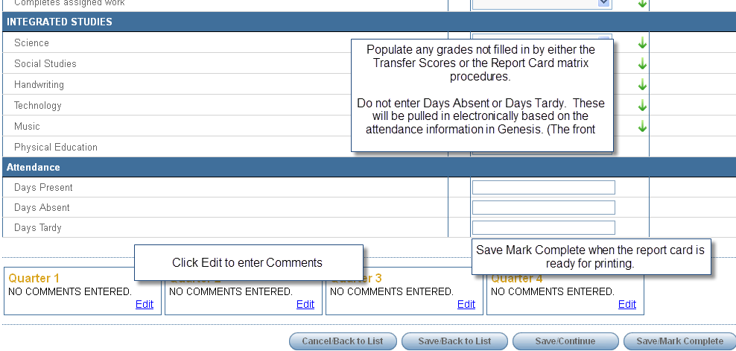

**Additional Topics:**

Grade Book Main

* Grade Book Main Navigation
* Grade Book Main Options

Assignment Views/Tasks

* Assignments
* Copy Assignments

Resources View

* Class Resources
* All Assignment Resources

Reports/Analysis

* Grade Book Reports
* Analysis Tool

Optional Setup:

* My Subjects
* My Assignment Types
* My Grade Book Comments
* Report Card Delegation
* Report Card Specialists