Schedule Based Grade Book

**Accessing Grade Book**

Log In to TeacherVue

Click the Icon to launch Gradebook 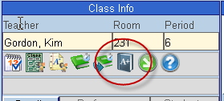

**Grade Book Setup**

Hover over the Grade Book Menu and select Grade Book Setup.

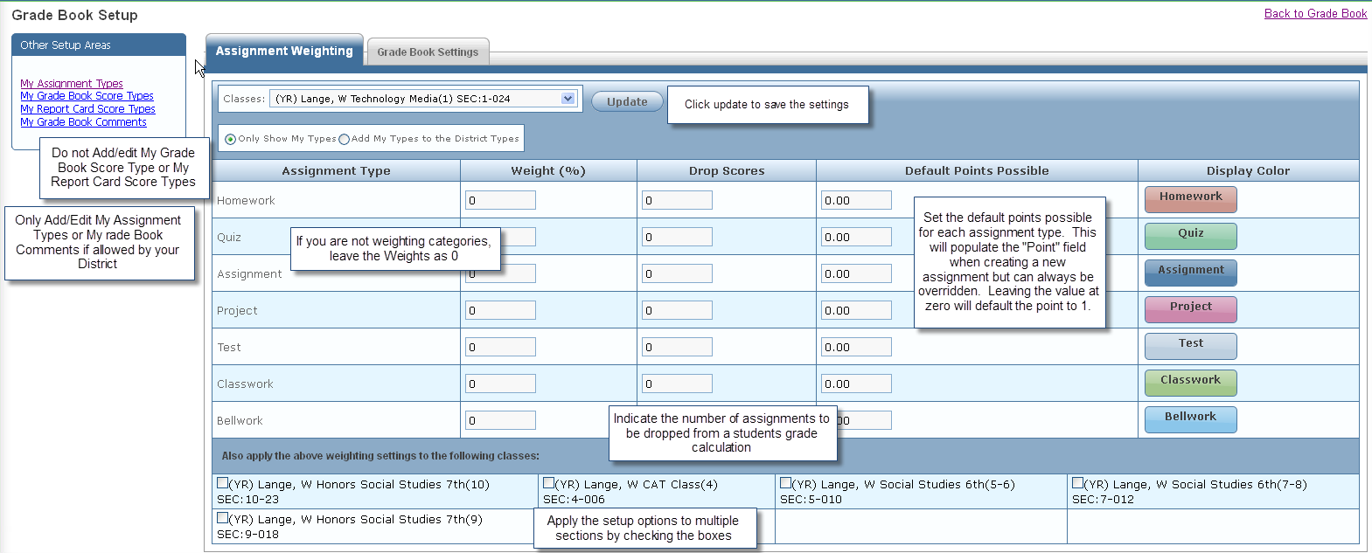

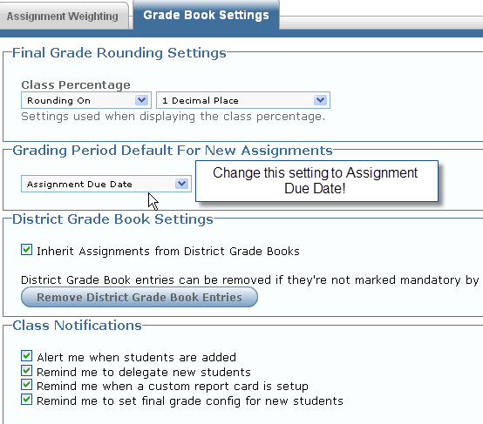

Notes:

**Creating Assignments**

Hover over the Grade Book Menu and select New Assignment or click on the New Assignment button from Grade Book Main.

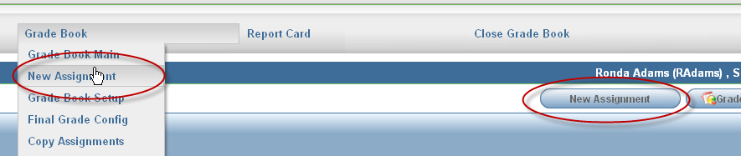

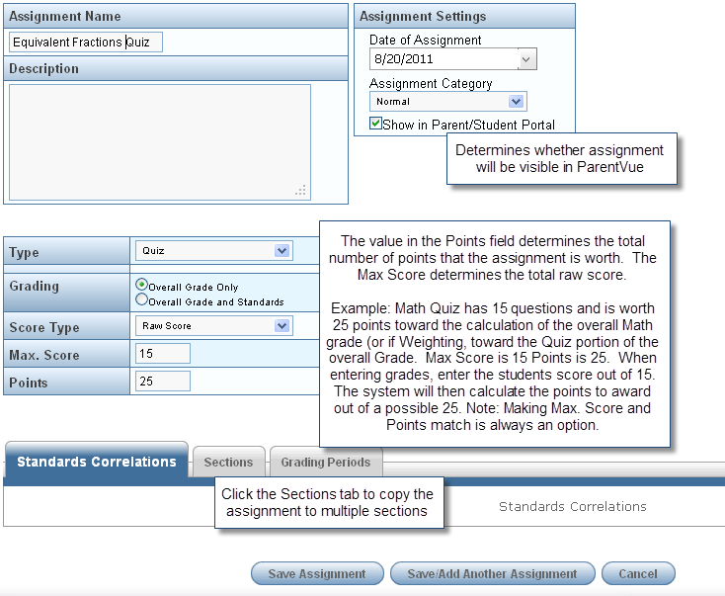

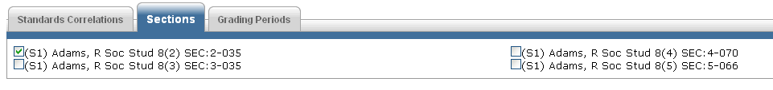

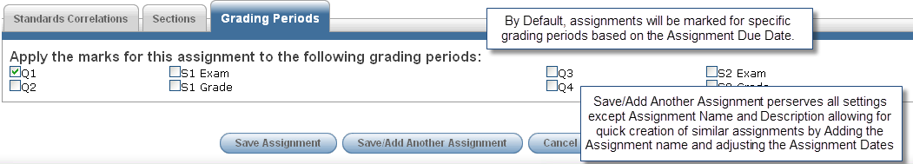

**Note: Multiple assignments may be created by selecting multiple sections, but assignments must be deleted individually from each applicable section.**

**Important Note for Schools including the Semester Exam Mark on the Report Card:**

If your setup includes a Semester Exam Grading period, make the Assignment Date/Due Date the day before the end of the semester and do not make any assignments due on the last day of the semester. This will ensure that the Semester Grade Calculates correctly.

Notes:

**Entering Scores**

From Grade Book Main, Click on the Heading of the assignment and Select Enter Scores

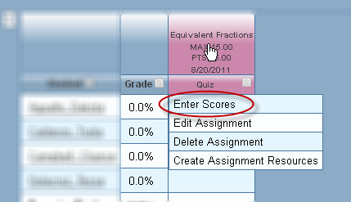

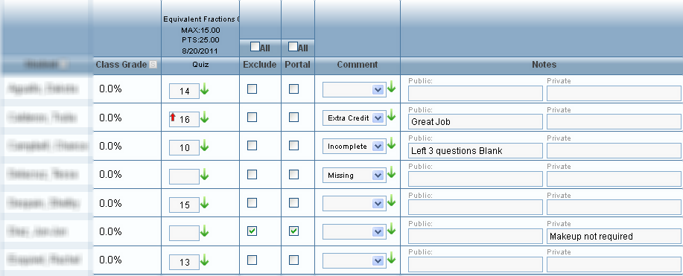

* Green (down) arrow fills the score or comment down from the arrow clicked.
* Red (up) arrow indicates score entered is higher than the max.
* Checking exclude drops the grade so that it doesn’t count for or against the student.
* Checking Portal hides the assignment so that it doesn’t show in Parent Vue.
* A “Missing” comment may be set to count as a “0”.
* Public Notes are visible in ParentVue.

**Entering Scores in Gradebook main in Grade Book Main**

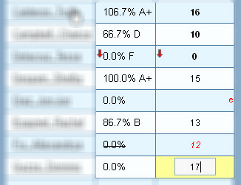

Click in cell, enter score. Score remains red and previously calculated grade is lined out until changes are saved.

The Red (down) arrow indicates the score fell below the “at risk” level.

Notes:

**Create Assignment Resources**

From Grade Book Main, Click on the Heading of the assignment and Select Create Assignment Resources

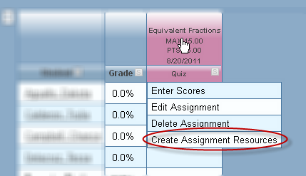

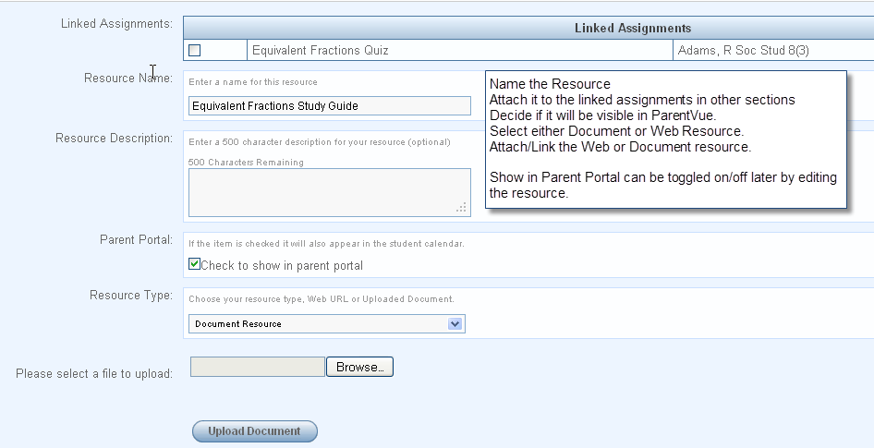

**Edit or Delete an Assignment Resource**

Click on the Column Heading of the Assignment that the resource is linked to and select Create Assignment Recourses. Existing resources are listed at the bottom of the window.

Click Edit (or Delete if desired)

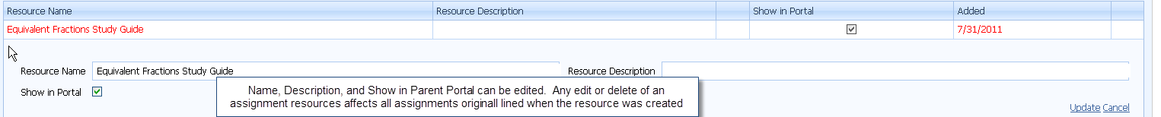

Notes:

**Posting Grades**

Teachers must post grades in order for progress reports and report cards to be generated. Depending on your districts eligibility procedures you may be required to post grades more frequently.

Hover over the Report Card Menu and Select Students



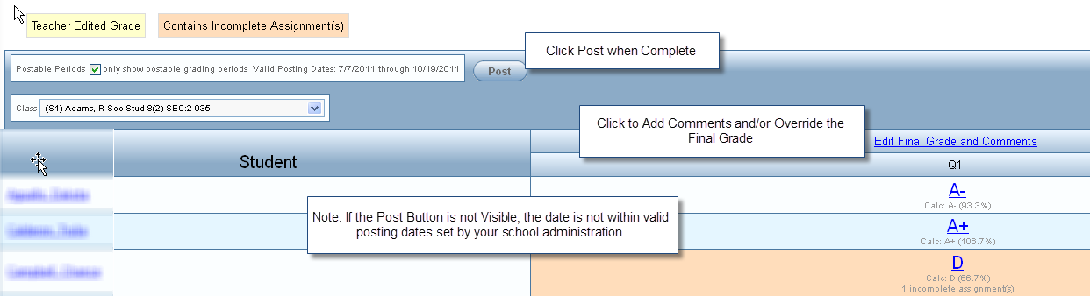

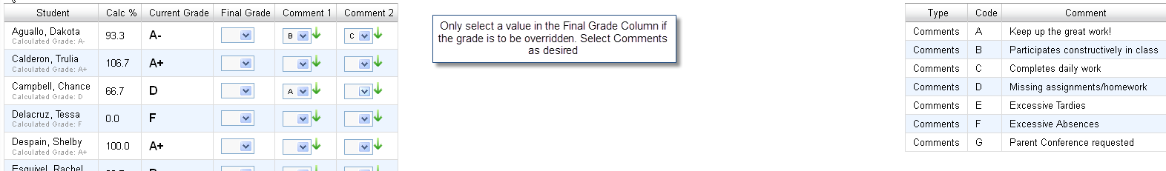

Note: Posting a second time overwrites any previous posting for that grading period.

**Additional Topics:**

Grade Book Main

* Grade Book Main Navigation
* Grade Book Main Options

Assignment Views/Tasks

* Assignments
* Copy Assignments
* Transfer Student Scores

Resources View

* Class Resources
* All Assignment Resources

Reports/Analysis

* Grade Book Reports
* Analysis Tool

Optional Setup:

* My Assignment Types
* My Grade Book Comments
* Final Grade Config
* Term Weighting