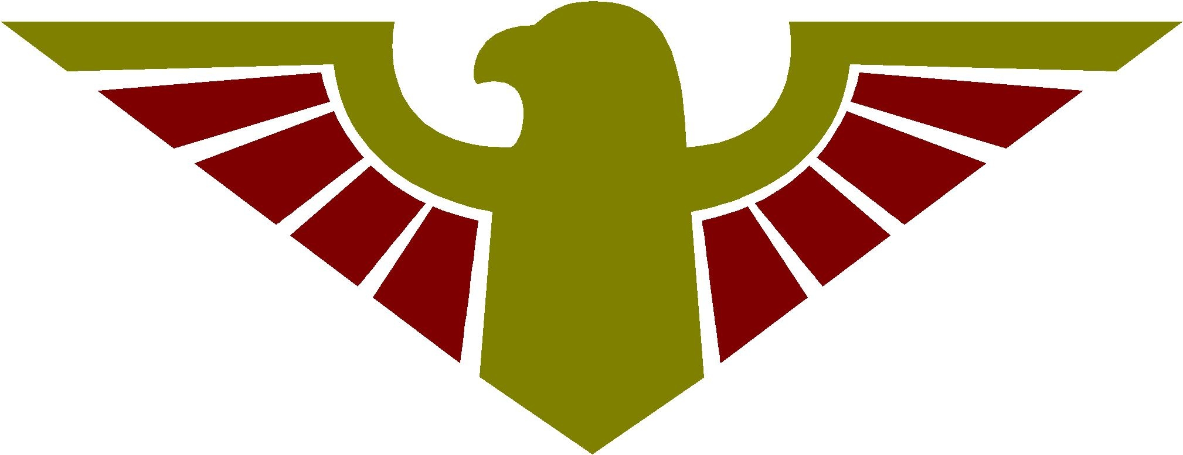
Puente de Hozho Behavior Reflection Form
(teacher keeps on file)

Student Name: _______________________ Date: _________________

Teacher Name: _______________________

Area where the Behavior Occurred: ________________________________________

1) Circle the expectation that you did not meet:

Safe Respectful Responsible Ready to Learn

2) What was the behavior you chose?

3) What were the consequences?

4) How do you feel about what happened?

Happy Worried Sad Other

5) How do you think your teacher and peers feel about what occurred?

Happy Worried Sad Other

6) What could you have done instead to show you are safe, respectful, responsible and ready to learn ?

_______________________ ________________________
Student Signature Teacher Signature

